1. windows - > other

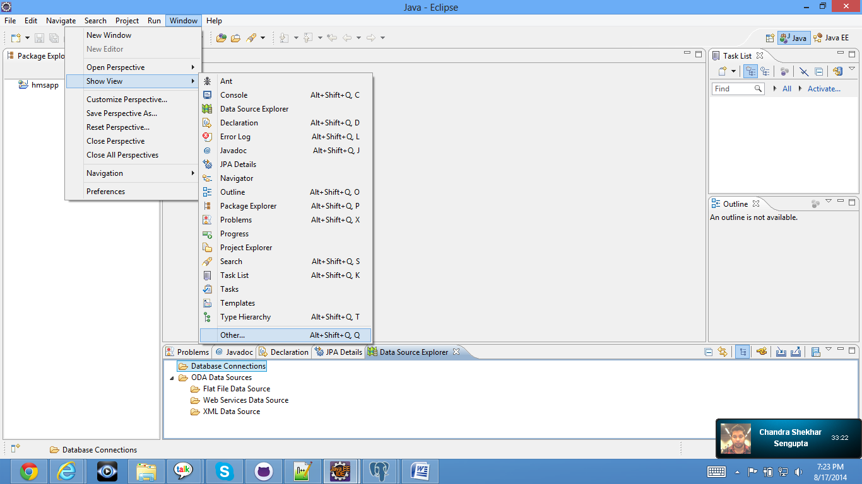

2. Click on Data source explorer